**Horizontal Truss # 1**

***Matlab***

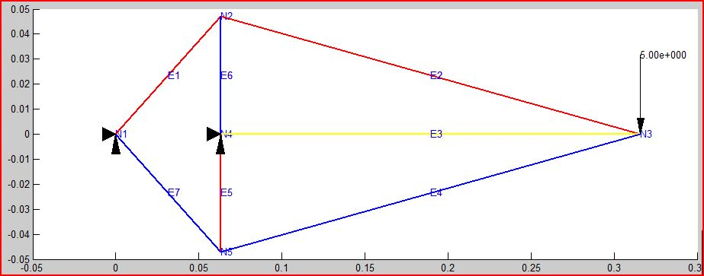

****Nodal Displacement Result******

Node Ux Uy Angle of Bending

1 -3.799e-029 2.904e-013 0.000e+000

2 2.745e-006 -7.754e-007 0.000e+000

3 -1.570e-022 **-4.092e-005** 0.000e+000

4 -3.167e-031 -7.754e-014 0.000e+000

5 -2.745e-006 -7.754e-007 0.000e+000

****Nodal Reaction Result******

Node Fx Fy Moment

1 1.332e-015 -2.008e+001 0.000e+000

2 -7.105e-015 3.118e-015 0.000e+000

3 1.610e-015 0.000e+000 0.000e+000

4 4.717e-016 2.508e+001 0.000e+000

5 8.882e-016 -5.329e-015 0.000e+000

***Solid Works***

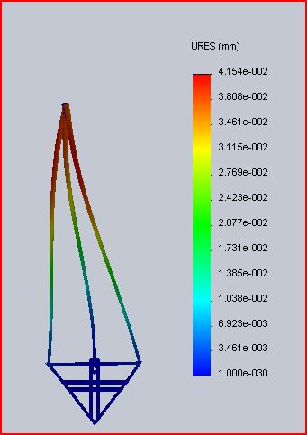

Max displacement (at tip) = -4.15 e-005 m